Identity and Access Management System

User Guide

Release 2

Division Name: | Information Technology
Branch / Unit: | Architecture Services

Creation Date: | May 01, 2017
Document Version: | 1.0

Document History
Document Location
https://healthshare.gov.ab.ca/sites/IAM

Revision History
Revision # | Revision Date | Change Author | Summary of Changes
1.0 | April 6 2017 | Vince Anderson | Release 2 (OpenIDM)

Content Contributors
Name | Project Role
Vince Anderson | IDM Architect
Perry Skavinski | IT Architect

Table of Contents
1. Introduction 4
1.1 Purpose 4
1.2 Intended Audience 4
1.3 Related Documents 4
2. IAM System Overview 5
2.1 IAM System 5
2.2 IAM Administrative Roles 5
2.2.1 Application Steward 5
2.2.2 IPC Administrator 5
2.2.3 IAM Administrator 6
2.2.4 Help Desk 6
3. Using the IAM System 7
3.1 How to Log In to Identity Manager (IDM) 7
3.2 How to Reset your Identity Manager account password (Forgotten Password) 10
3.3 How to Change your account passwords 13
3.4 How to Log In to a protected application 16
3.5 How to Log Off from a protected application 18

Introduction

Purpose
This guide explains how to use the Alberta Health (AH) Identity and Access Management (IAM) System Release 2 incorporating the migration from the previous Sun-based software solution to ForgeRock’s OpenIDM software.

Intended Audience
This guide is primarily intended for the end user with non-technical background on IAM or IAM products. However, basic knowledge about AH's applications and processes is expected in order to use this guide.
- Business Users – are persons who access protected applications, reset their own passwords, unlock their own accounts, and set their own challenge and response questions.
- Requesters – are persons who submit requests in the IAM System. (eg, Application Stewards, IAM Application Steward, etc.)
- Approvers - are persons who provide first or second level of approval to provisioning requests. (eg, Application Stewards, IPC Administrators, etc.)

Related Documents
Additional information about the AH's IAM System can be found at https://healthshare.gov.ab.ca/sites/IAM, specifically within the following documents:
- AHW Identity Management Process Models Current State version 2.1, 07/16/08
- AHW Identity and Access Management Business Requirements version 1.2, 11/28/08
- AHW Identity and Access Management System Detailed Design Specifications Release 0 version 0.6, 05/11/09

IAM System Overview

IAM System
The IAM system uses a combination ForgeRock’s OpenIDM (Identity Manager) and OpenAM (Access Manager). The Identity Manager component of the IAM system provides user account management, password management, reports and auditing services. The OpenAM component provides authentication and authorization services to enable users to access AH’s web applications.

IAM Administrative Roles

Application Steward
An Application Steward is identified for each existing web application. The Application Steward is responsible for the ongoing stewardship of the application after its implementation through to the end of its useful life. This role is intended to ensure that the application operates effectively and meets business requirements on an ongoing basis. The following Application Steward roles have been defined:
- Application Steward for each individual application – Approve or Deny requests to access that application. In addition, this role can submit requests on behalf of Business Users to:
  - Register OpenIDM account
  - Upgrade account - add application-specific roles
  - Downgrade account - remove application-specific roles
- IAM Application Steward – Maintain and run reports, and can submit requests on behalf of Business Users to:
  - Register OpenIDM account
  - Upgrade account – add application groups
  - Downgrade personal account – remove application groups
  - Suspend personal account
  - Enable account
  - Delete personal account
  - Reset password of personal account

IPC Administrator
This role is assigned to a person responsible for Approving or Denying requests to access any AH business applications.

IAM Administrator
A role assigned to a person responsible for providing IAM operations support. The IAM Administrator is the superuser in OpenIDM, and can among other things:
- Perform Help Desk operations
- Perform system and maintenance operations within Identity Manager, like access the system log, import or export accounts, define new roles, assign Application Stewards, etc.

Help Desk
The Help Desk is a single point of contact that provides general information and assistance to employees and contractors for troubleshooting problems with computers and similar resources. A person who has a Help Desk role assigned can submit requests on behalf of Business Users to:
- Register OpenIDM account
- Upgrade account – add application groups
- Downgrade personal account – remove application groups
- Suspend personal account
- Enable account
- Delete personal account
- Reset password of personal account

Using the IAM System

How to Log In to Identity Manager (IDM)

NOTE: You can log in to IDM if you have a user account created in IDM and your login credentials have been provided (user ID and password).

To log In to IDM, follow these steps:
- First, open your browser and enter the IDM URL path to display the login page of the IDM application.
- If accessing from within the AH’s network:
  - QA URL: https://iama1.health.alberta.ca/idmuser/
  - Production URL: https://iam1.health.alberta.ca/idmuser/
- If accessing from the Internet (require RSA fob):
  - QA URL: https://iama2.health.alberta.ca/idmuser/
  - Production URL: https://iam2.health.alberta.ca/idmuser/

- Once the login page is displayed, enter your user ID and password. Click on the Log In button to submit your request.
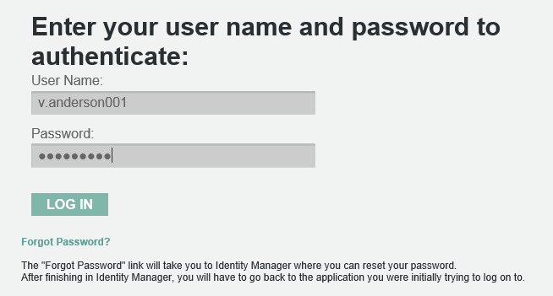
- If this is the first time you are logging in, you will be prompted to answer five security questions. The responses will be saved and used in future operations (e.g. Forgotten Password) to validate user authenticity. It is important that you remember your answers as these questions are used to authenticate you if you forget your password.
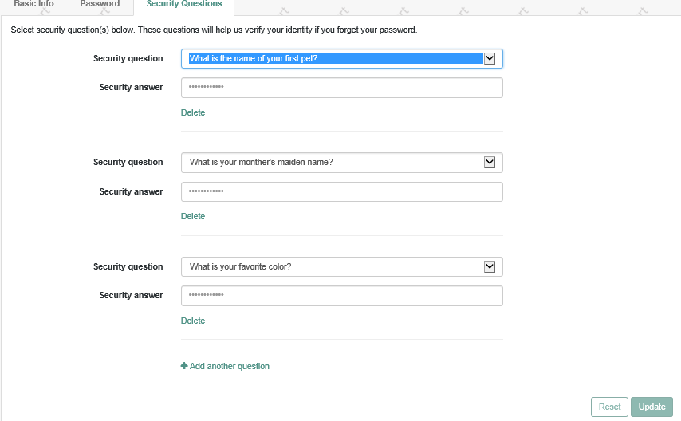

- IDM will verify your credentials (user ID and password) and if you have valid access permission, the IDM User interface will be displayed.
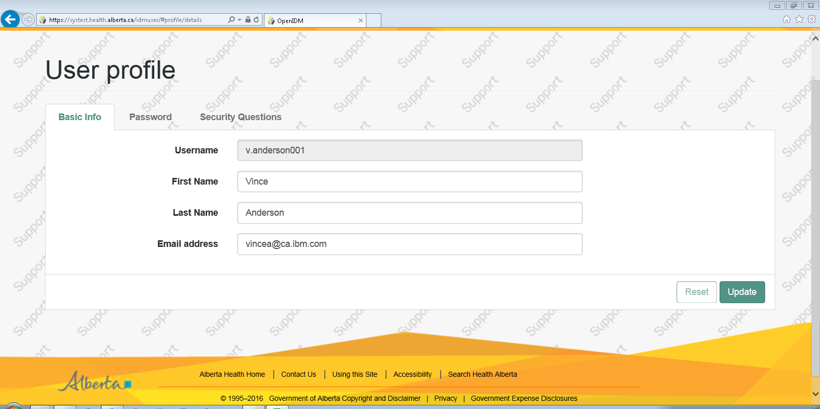

In the above picture, the IDM User interface is presented.

What if you cannot log in to IDM?
The following are possible reasons why you cannot log in to IDM:
- If you entered an invalid password, you can try entering your password again. However, a limit of five attempts is allowed, after which your account will be inactivated.
- If your account is already inactive or you are not authorized to access IDM, you must contact Help Desk.

How to Reset your IDM account password (Forgotten Password)

To reset your IDM password, follow these steps:
- First, open your browser and enter the IDM URL path to display the login page of the IDM application.
- See first step in section 3.1 How to Log In to IDM.

- Once the login page is displayed, enter your user ID and click on Forgot Password to submit your request.
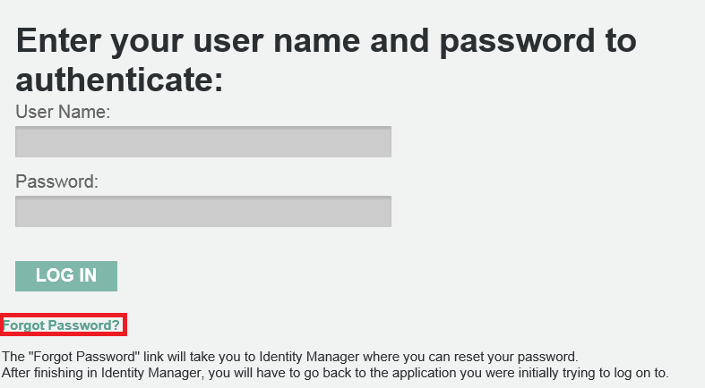

- A Reset Your Password page is displayed asking you to identify yourself to IDM. Enter either your user ID or your email address (the one associated with your IDM account) or your complete first and last name. Click Submit.
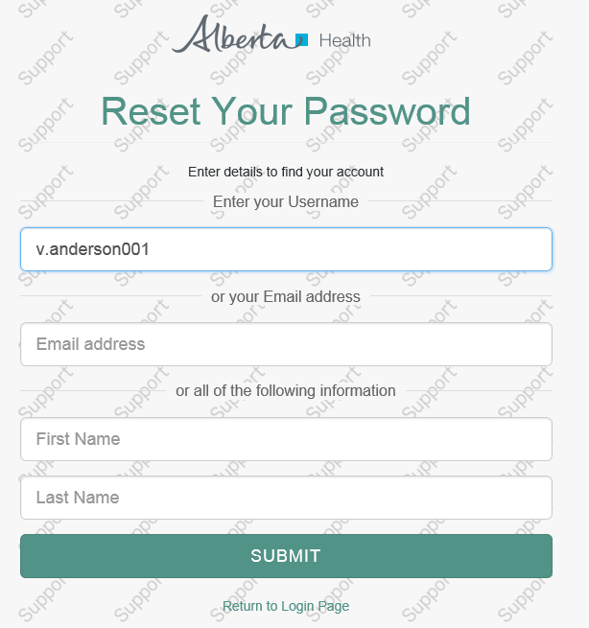
- You will be asked to answer two of five questions that you previously recorded during your initial login to IDM (see Section 3.1). Enter your answers and click on the Submit button to submit your request.
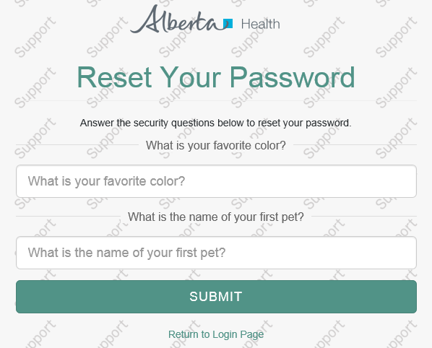

- If your answers are correct, the Change Password page is displayed. You must enter a new password (twice) and click on the Submit button to submit your changes.
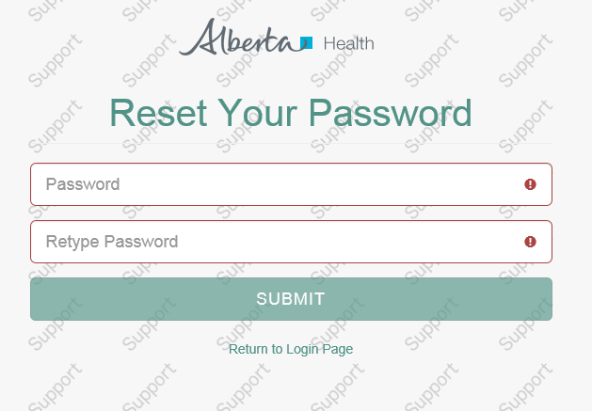

- A new page is displayed, confirming that your password has been changed.
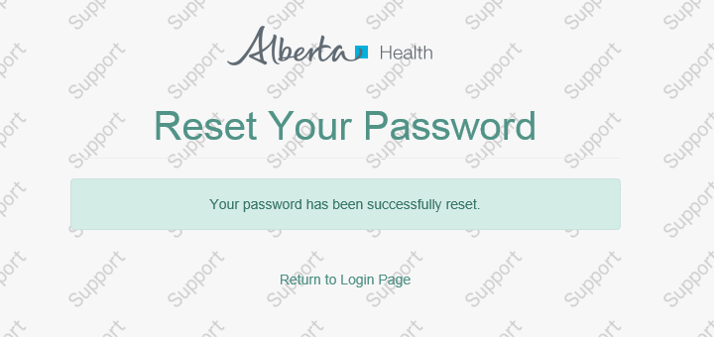
Click on Return to Login Page to log into IDM.

What if you cannot change or reset your password?
The following are possible reasons why you cannot change or reset your password:
- If your answers in the Identify User page are invalid, the IDM system will display an error message and will prompt you to try again.
- The system will not allow you to enter a new password that does not comply with current password policies.

How to Log In to a protected application

NOTE: In order to log in to a protected application you need an approved application-specific role assigned.
To log in to a protected application, follow these steps:
- First, open your browser and enter the URL path of the portal page.
- If accessing from within the AH’s network:
  - QA Portal URL: http://portal4.albertawellnet.org/
  - Production Portal URL: http://portal2.albertawellnet.org/
- If accessing from the Internet (require RSA fob):
  - QA Portal URL: http://portal3.albertawellnet.org/
  - Production Portal URL: http://portal1.albertawellnet.org/

- Locate the appropriate application and click on the link.
- Once the login page is displayed, enter your user ID and password. Click on the Log In button to submit your request.

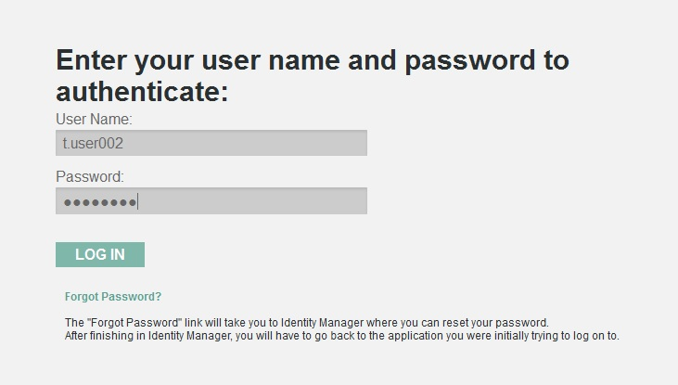

- The requested application page is displayed.
What if you cannot log in to the protected application?
The following are possible reasons why you cannot log in to a protected application:
- The User Id or Password is incorrect. Make sure to enter a correct User Id and Password.
- Your account is inactive.
- You do not have permission to access the protected application. If you have been assigned application access and you cannot log in, please contact the Help Desk or the appropriate Application Steward.

How to Log Off from a protected application

To log off from a protected application, follow these steps:
- Click on the Logout or Logoff button to exit the protected application. Note that if you are logged into multiple IAM applications you will be logged out of all of them.
- You will be redirected to the IAM login page (see below). To log back on, you will have to enter your User Id and Password again.
- If the Logout/Logoff button does not work or does not take you to the IAM login page, then you can close your browser to close your application session.
- Also, after 30 minutes of no activity in the application, your next action in the application will redirect you to the IAM login page where you will have to enter your User Id and Password again.

